Уфимский Государственный Авиационный

Технический Университет

The review of network UMTS

Выполнил: Абзалов А. В.,

группа ТКС-207,

2 курс, ФАП
Проверила: Лашманова Н. Н.

Уфа – 2006
Contents

1 Introduction 3
2 Standartisation 6
3 Version UMTS 6
4 Services given in a network UMTS 7
4.1 General services 7
4.2 Quality of service 7
4.3 Opportunity UMTS in granting services 7
4.3.1 Services based on a site 7
4.3.2 Service WAP 8
4.3.3 Service of an exchange multimedia by the messages (MMS) 8
4.3.4 CAMEL 8
4.4 Virtual home environment (VHE) 8
5 Network components of a network UMTS 9
5.1 Elements of a network of access 9
5.2 Architecture of a network of radio of access GSM/EDGE (GERAN) 9
5.2.1 Subsystem of base stations (BSS) 10
5.2.2 Base accepting and transmitting station (BTS) 10
5.2.3 Controller of base stations (BSC) 10
5.2.4 Mobile station GSM (MS) 10
5.3 Architecture of a universal ground network of radio of access (UTRAN) 10
5.3.1 Subsystem of a network of a radio communication (RNS) 11
5.3.2 Controller of a network of a radio communication (RNC) 11
5.3.3 Unit B 12
5.3.4 Equipment of the user (UE) 12
5.4 Elements of a base network 12
5.5 Elements of a base network - domain of switching of channels (CS) 13
5.5.1 Centre of switching of mobile communication / the sluice centre of switching of mobile communication (MSC/GMSC) 13
5.5.2 Sluice of environment / server of the centre of switching of mobile communication (MGW/server MSC) 13
5.5.3 Sluice of the signal system (SGW) 14
5.6 Elements of a base network - domain of switching of packages (PS) 14
5.6.1 Serving unit of support GPRS (SGSN) 14
5.6.2 Sluice unit of support GPRS (GGSN) 15
5.7 Elements of a base network (CN) - Registers 15
5.7.1 Home register (HLR) 15
5.7.2 Server of the subscribers of a home network (HSS) 15
5.7.3 Guest register (VLR) 16
5.7.4 Centre outidentification (AuC) 16
5.7.5 Register of identification of the equipment (EIR) 16
5.8 Subsystem IP-multimedia (IMS) 16

The review of network UMTS

The description of base principles of construction of mobile networks of communication of 3-rd generation on base UMTS.
The standard of mobile communication of 3-rd generation - UMTS (Universal Mobile Telecommunication System) or 3G is a large step forward in the field of acceleration of transfer of the data and maintenance of opportunities of association of a speech signal and data at a new level allowing giving multimedia of broadband service. At the same time UMTS puts before the manufacturers and operators of mobile communication the large problems connected to complexity of technical realization and huge expenses for an infrastructure.
The given materials of the company NetTest represent the characteristic of the newest technologies. In too time they can be used as a brief help management on many difficult questions concerning UMTS.
In the chapters 1 - 3 the technology UMTS is considered and the structure of network interfaces and protocols, and also functionalities of a network and procedure of the signal system is in detail described.
In the chapters 4 and 5 the key aspects UMTS are considered: maintenance of privacy and quality of service.
In the chapter 6 the offers of the company NetTest under the control and optimization of a network UMTS, called are briefly stated to help the clients to feel is more sure in conditions of a rigid competition, allowing the operators of mobile communication to decide questions of diagnosing of malfunctions and optimization of the operational characteristics of a network.

The review of network UMTS

1 Introduction
The communication always had the large importance for mankind. When there are two men, the vote suffices for dialogue to them, but at increase of distance between them there is a need for special tools. When in 1876 Aleksandr Grehem Bell has invented the telephone, the significant step which has allowed communicating two people was made however for this purpose it was necessary to them to be near to the permanently established telephone device! More than hundred years wiresly of a line was a unique opportunity of organization of telephone communication for the majority of the people. The systems of a radio communications not dependent on wires for organization of access to a network, were developed for the special purposes (for example, army, police, marine sea fleet and the closed networks of an automobile radio communication), and, eventually, have appeared the systems which have allowed the people to communicate on the phone, using a radio communication. These systems intended mainly for the people, go by machines, and for steel are known as telephone systems of mobile communication.
In the beginning 1980 years in many European countries the fast growth of telephone systems of mobile communication of the first generation (1G), based on analog technology began. In each country the own system incompatible to others from the point of view of the equipment and functioning was developed. It has resulted that there was a necessity for creation of general European system of mobile communication with high throughput and cover zone of all European territory. Last meant, that the same mobile telephones could be used in all European countries, and that the entering calls should automatically be directed to the mobile telephone irrespective of a site of the user (automatic rouming). Besides it was expected, that the uniform European market with the general standards would result in downturn of the prices on the user equipment and network elements irrespective of the manufacturer. And, at last, use of modern digital technology should result in reduction of dimensions of portable devices both improvement of functionalities and quality.
In 1982 CEPT (the European conference of post and telecommunication departments) has generated working group named as special group on mobile communication (GSM) for study and development of the пан-European ground system of mobile communication of general application - the second generation of systems of a cellular telephony (2G). The name of working group GSM also began to be used as the name of system of mobile communication. In 1989 of a duty CEPT were transferred in ETSI (European institute of the standards in telecommunication). Originally GSM intended only for the countries - members ETSI. However many other countries also have the realized system GSM, for example, East Europe, Average East, Asia, Africa, Pacific Ocean region and Northern America (with derivative from GSM, named PCS1900). The name GSM now is meant "by global system for mobile communication", that meets to its essence.
Evolution of mobile telephony
1G | 2G | 3G
- analog telephony  - mobility  - base services  - incompatibility | - digital telephony and message transfer  - mobility and rouming  - support of transfer given  - additional services  - floor global the decision | - broadband transfer of the data and transfer of speech under the protocol IP (VoIP)  - mobility and rouming  - the service concept and models  - the global decision
with 1980 | with 1990 | with 2000
Having begun with ten, the systems GSM had enormous success and were widely developed in the majority of parts of the world. This system well approaches for organization of telephone communication, and also is widely used care of the information by a service of the short messages (SMS). The system GSM also gives services of transfer of the data with switching of channels, as integrated wireless the access to services of telephony and transfer of the data was one of the purposes of this system. However offered speed of access (maximum 9600 bod) has limited opportunities of use of system GSM care of the data. ETSI has determined some decisions for improvement of system of mobile communication care of the data frequently named 2.5G. It was made to show movement forward in comparison with GSM, but these systems are still closely enough connected with GSM: HSCSD (high-speed transfer of the data with switching of channels), GPRS (general services of a batch radio communication) and EDGE (transfer of the data with the increased speed for evolution of global system / GSM).
The system HSCSD is the elementary modernization of system GSM, intended care of the data. As well as GSM, this system is based on connections with switching of channels, but best use of an accessible pass band and assignment more than one time interval on connection allows to increase speed of transfer of the data - theoretically up to 57.6 kbit/s. However method of switching of channels of system HSCSD is inefficient by transfer of the data, since the traffic of the data is focused on batch transfer.
The system GPRS is developed as system of batch transfer of the data with theoretical maximal speed of transfer about 170 kbit/s. GPRS coexists a network GSM, reusing base structure of a network of access. The system GPRS is expansion of networks GSM with granting of services of transfer of the data on an existing infrastructure, while the base network extends at the expense of imposing new components and interfaces intended for batch transfer. The system GPRS supports the combined services of a telephony and transfer of the data and gives services multimedia.
The system EDGE is modernization of system GSM/GPRS, modulation, using a new method, for radio of the interface, which allows considerably to increase speed of transfer on radio the interface. System EDGE will increase theoretical maximal speed of transfer of the data up to 384 kbit/s.
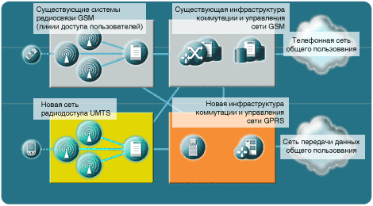
Pic. 1 Interrelation between networks GSM (2G), GPRS (2.5G) and UMTS (3G)
The universal system of mobile communication (UMTS) is cellular telephone system of the third generation (3G), intended not only for improvement and acceleration of mobile communication. The system UMTS also provides a new way of granting of a combination of services of a telephony and transfer of the data, for example, promoting introduction multimedia and through broadband services. In a result UMTS will mean the following for the operators and their clients:
UMTS for the consumers:
· radio access worldwide with the help of one tiny telephone
· wide set multimedia of services with the appropriate degrees of quality
· the standards of mobile communication of the third generation will allow the users on complete capacity to use opportunities of the Internet at the expense of effective high-speed transfer of a radio signal optimized for multimedia
· UMTS will transform dream of universal communication into a reality
UMTS for the operators:
· unification of various systems of wireless access existing now, in a flexible infrastructure of a radio communication
· evolution from early "existing" systems guaranteeing global economy at escalating and delivery, at the same time providing:
– Ample opportunities for differentiation of production and services;
– Choice of methods of radio of access and base networks for flexible realization and development of systems based on the requirements of regulation, market or business for each region or country.
As to the operators, there is a huge difference in capital investments required for maintenance of system 2.5G (GPRS) in comparison with system 3G. For realization of system 2.5G the insignificant investments for updating a network of radio of access and additional equipment (for a base network with switching of packages), installed atop of existing networks GSM are required, whereas for systems UMTS the very large capital investments are required, as the basic part a network should be created from the very beginning. For system EDGE huge investments also are required, as it is necessary to create a new network of radio of access.
It is more attractive to the existing operators GSM of technology 2.5G, as they can be realized on the basis of those licenses, which the operators already have, whereas for UMTS the new licenses (and in several areas) are required. For the users the system GPRS becomes the important step in the direction of new services, whereas UMTS serves mainly for expansion of these services. Therefore success GPRS and services, offered it, becomes the important parameter what services will result in success the future networks UMTS 3G.

2 Standartisation
One of driving forces for UMTS is the requirement of creation of really universal system. That is why work on standartisation was allocated from ETSI in new organization "the Project of cooperation on creation of system of the third generation" (3GPP) with participation of regional and national organizations on standartisation. The additional company processes the reasons about a condition of the market - "the Participants - representatives of the market" (MRP).
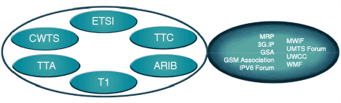
Pic. 2 Organizations, which are included in 3GPP
The organization 3GPP creates the general standard, were based on given, received from organizations-participant. The group on harmonization of the operators (OHG) was based to find the compelled compromises in a case, when the organizations in 3GPP are not capable to reach the agreement. Besides these organizations there is an organization "the Project of cooperation on creation of system of the third generation number 2" (3GPP-2), which guarantees acceptance in account of systems based on north ameriсan of technology of a radio communication IS-95.
Though the system UMTS is based on existing networks GSM/GPRS, it adds some new components and interfaces to a base network. A network of radio of access completely new, based on new technology WCDMA (broadband multiple access with code division of channels), spectral strip, giving the best use, in comparison with today's technology GSM. It allows to provide higher speeds of transfer of the data, large throughput, and, hence, and to serve a lot of the subscribers. At the end, UMTS will result in complete reorganization of a base network GSM/GPRS/UMTS, as the universal IP-technology will be created.

3 Version UMTS
In process standartisation UMTS in 3GPP the system was determined by a set of stages - or versions. While three versions are determined: UMTS of the version 1999 of year (R99 - sometimes named by the version 3/Rel-3), UMTS of the version 4 (Rel-4) and UMTS of the version 5 (Rel-5). In figure in section 1.5 representing architecture of a network, the influence of the versions on a network is shown. The versions UMTS are the three basic representatives of the authorized requirements from 3GPP.
The basic features of each version:
R99
· determines a universal ground network of radio of access (UTRAN) UMTS
· existing network GSM/GPRS the subsystem of a network of a radio communication (RNS) is added
· the base network (CN) is an existing network GSM/GPRS with some improvements
Rel-4
· the version 4 enters of a sluice of environment (MGW), server of the centre of switching of mobile communication (MSC) and sluice of the signal system (SGW). It will allow logically to divide the user data and information of the signal system in MSC
· will be carried out improvement UTRAN, which include support of high speeds of transfer given even in local areas, up to 2 Mbit/s
Rel-5
· the subsystem IP-multimedia (IMS) is added
· the home register (HLR) replaces / supplements of server own ("home") the subscribers (HSS)
· the improvements UTRAN, ensuring effective services multimedia on base IP in UMTS are entered
· the introduction IubFlex (provides controllers of a network of a radio communication (RNC) for connection more than one complete set of Units B)
· improvement of services by definition of a site (LCS)
· the universal IP-network, at the end, becomes a reality
· the version 5 is based on the protocol IP of the version 6 (IPv6)
The above-stated versions are in the "frozen" condition. It means, that the versions admit, if the correction is necessary (i.e. the new functionalities are not added any more). The version 6 and above with the following features is planned: they concern areas similar to improvements IMS, integration of wireless local networks (WLANI), convergention of the Internet (concerning protocols and services), broadcasting / multiple-address multimedia of services (MBMS) and evolution in a network only within the limits of area of batch switching (PS).
The data of a note address mainly to the version 4. However other versions will be mentioned in some cases to allocate the basic differences from the version 4.

4 Services given in a network UMTS
As the network UMTS develops, it will be given ever more and more services. The network of mobile communication UMTS of the version 5 will give services similar of themes, which are known today from the Internet, for example, floun video, transfer of speech under the protocol IP (VoIP), videoconference and interactive services. The part of a network which is carrying out switching of channels, will be replaced by technology of batch transfer (very much reminding IP) for maintenance of higher speeds of transfer of the data and increase of flexibility of a network. The part of a network which is carrying out switching of packages, remain without change, but the new batch domain will be added: a subsystem IP-multimedia (IMS).

4.1 General services
The base services given UMTS, are similar to services known from GSM and ISDN (a digital network with integration of services). Using definitions from MSE-T, the services can be shared into services of carry, teleservice and additional services. The basic base service given UMTS, is the telephony. Similarly to other transmitted data, the digital coding of speech is carried out which then is transferred on a network as a digital flow. The set of services of transfer of the data realized as transfer of the data with switching of packages is offered. A service of the short messages (SMS), entered together with GSM also will be accessible. The additional services are given atop of teleservices, for example:
· back address/exception/installation of a call on expectation / deduction
· service of tripartite communication
· the Information on payment
· identification of the causing subscriber
· of Group of the closed users

4.2 Quality of service
One of achievement of networks 2.5G and 3G - maintenance better transfers of the data. For achievement it both in GPRS, and in UMTS the concept of quality of service (QoS) as the integrated part of system is entered. The presence of the effective mechanism QoS "on places" will allow the operators of mobile communication economically to give high-quality, differencial of the appendix and service on base IP.

4.3 Opportunity UMTS in granting services
The way of organization UMTS assumes branch, as far as it is possible, part of a network which is carrying out actual connections, from a part ensuring granting of services. It promotes the greater openness and increase of potential in conditions of the market, provides the concept of the separate suppliers (providers) of the information, services and telecommunication companies. Some of these services are resulted below.

4.3.1 Services based on a site
The geographical situation of the equipment of the user (UE) can be determined by measurement of a level of radio signals. The functions of positioning for optimization of the operational characteristics of system of a radio communication can be used inside a network UTRAN, additional network services, itself UE or on all extent of a network and services "of the third party". The following services concern to typical commercial services:
· the information on movement of urban transport
· management of park of a vehicle
· "follow me"
· "the Nearest service"
· services of emergency calls
The schedulers of a network UMTS also can use this information.
The services based on a site, can be realized in networks GSM/GPRS on the basis of transfer of the information of the signal system between a network and mobile station (MS is by an equivalent UE in networks GSM/GPRS).

4.3.2 Service WAP
The protocol of an applied level for a radio communication (WAP) - is the protocol of access to the Internet optimized for a mobile telephony. It provides to the user of mobile communication access to the information and services of the Internet in any place and at any time, for example, the electronic mail, time-table of flights etc. Service WAP gives to the user web-browser, which uses language of marks of a radio communication (WML) instead of hyper-textual language of marks (HTML), usually used in the Internet. Language WML is developed for use with mobile terminals. The sluices in system care of transformation between a format WAP and usual format of the Internet.

4.3.3 Service of an exchange multimedia by the messages (MMS)
The service of an exchange multimedia by the messages (MMS) is used for delivery multimedia of the messages in UE from anyone another UE, from stationary item in the Internet or from the supplier of additional services (VAS). Additional services can be news, weather forecasts, the information from a share stock exchange etc. Except for the text multimedia of the message all types multimedia, for example, speech, video, audio and static images can contain.

4.3.4 CAMEL
The extended logic of the specialized appendices for networks of mobile communication (CAMEL) is a general platform for set of services for the consumers. It provides a network UMTS with functions of an intellectual network (IN) similar to the following:
· an advance payment
· a filtration of calls
· supervision (control)
CAMEL gives the information necessary for realization of an exchange between networks (for function IN usually are specific network functions). The traditional decisions IN create services on the basis of switching channels. CAMEL will make too most, and also to carry out interaction with connections on the basis of batch switching.

4.4 Virtual home environment (VHE)
VHE is a concept of granting of services in limits UMTS, which allows the user to have the same personal interface with a network, not paying attention to an accessible network. It is required, that the networks should transfer the information on structures of the users, about the tariffs, services and multiple compatibility, which, considering complexity of networks, is a uneasy task. There where for VHE the gateway interaction is required, will be used CAMEL.

5 Network components of a network UMTS
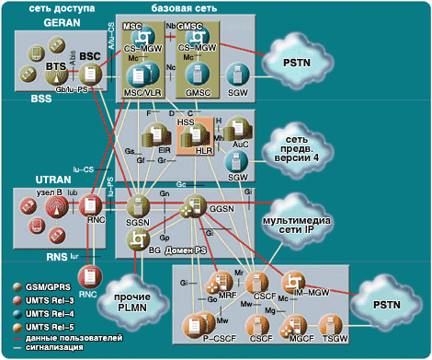
Pic. 3 Architecture of networks GSM/GPRS/UMTS
In figure some of subsystems in networks GSM/GPRS/UMTS are above shown, as they will develop together with the versions UMTS. On the party of a network of access there is a subsystem of base stations (GERAN) for GSM/GPRS and RNS (UTRAN) for UMTS. The base network (CN) is under construction on the basis of a base network GSM/GPRS, but as shown, in networks UMTS of the version 4 and 5 some subsystems and components will be modernized, and also will be added new. It will allow the operators of existing networks GSM/GPRS to take benefit from improved economic UMTS, at the same time protecting the capital investments in system 2G and reducing risks from introduction. In a network there are also other elements, such as elements of services of definition of a site, which are used for account of a site.
The network GSM/GPRS/UMTS cooperates with other ground networks of mobile communication of general usage (PLMN), including networks previous versions 4 switched telephone networks of general usage (PSTN) and others multimedia of a network on base IP.

5.1 Elements of a network of access
For a network GSM/GPRS/UMTS two types of a network of access are determined: BSS - is used for networks of access GSM, GPRS and EDGE (GERAN), and RNS - is used for access WCDMA.

5.2 Architecture of a network of radio of access GSM/EDGE (GERAN)
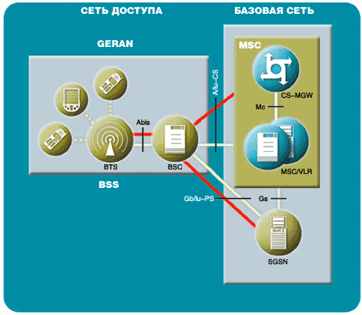
Pic. 4 Architecture GERAN
GERAN is a network of access determined for GSM, GPRS and EDGE. GERAN is connected to a base network (CN) GSM a Stage 2 + or through two traditional interfaces (A-interface and interface Gb), or through interfaces Iu. The interface between GERAN and domain PS of a base network (Iu-PS or traditional interface Gb) is used care of the data by a method of switching of packages, and the interface between GERAN and domain of switching of channels (CS) of a base network (Iu-CS or traditional interface A) is used care of a speech signal or data by a method of switching of channels.

5.2.1 Subsystem of base stations (BSS)
BSS or GERAN is a system of the equipment of base stations (transceivers, controllers etc.), which answers for interaction with mobile stations in the certain zone. BSS is connected to MSC with the help of one interface A or Iu-CS. By a similar image in networks PLMN, supporting GPRS, BSS is connected to serving unit of support GPRS (SGSN) with the help of one interface Gb or Iu-PS.
The equipment of a radio communication BSS can support of one or more cells. BSS can include one and more base stations. There where the interface Abis is realized, BSS includes one controller of base stations (BSC) and one or more base accepting and transmitting of stations (BTS). The interaction BTS and BSC is carried out through the interface Abis.

5.2.2 Base accepting and transmitting station (BTS)
BTS includes radio transmitters and receivers (transceivers - TRX), networks, covering determined geographical zone, GSM (zone of base station including one or more radio of cells). BTS processes the protocols of radio of a link with the help MS.

5.2.3 Controller of base stations (BSC)
BSC operates group BTS at adjustment of the radio channel, management of a level of capacity, to spasmodic reorganization of frequency and transfer of service - carry of the established connection from one radio channel in another it is usual as a result of moving MS from an operative range of one base station in an operative range another. BSC is a connection between mobile station and MSC.

5.2.4 Mobile station GSM (MS)
The mobile station GSM includes the equipment of mobile communication (terminal) and card of the module of identification of the subscriber (SIM). The SIM-card provides personal mobility, giving the user access to the signed services, irrespective of the concrete terminal. The international identifier of the equipment of mobile communication (IMEI) identifies the equipment of mobile communication by a unique image. The SIM-card includes the International identifier of the subscriber of mobile communication (IMSI), used for identification of the subscriber in system, confidential key for outidentification and other information. IMEI and IMSI are independent, thus, providing personal mobility. MS cooperates with a network GSM till radio to the interface (interface Um).
As to UMTS, the mobile station should work in one of two modes:
· mode based on interfaces A/Gb between BSS and CN, for example, for:
– terminals of the version previous version 4
– terminals of the version 4 at connection to BSS without the interface Iu in a direction to CN
· mode based on interfaces Iu-CS and Iu-PS between BSS and CN for:
– terminals of the version 4 at connection to BSS with the help of interfaces Iu in a direction to CN

5.3 Architecture of a universal ground network of radio of access (UTRAN)
For UMTS R99 the new network of radio of access UTRAN was entered. The network UTRAN is based on technology WCDMA, entered to achieve more effective utilization of throughput in comparison with methods used in GSM/GPRS. The network UTRAN is connected to a base network GSM a Stage 2 + through the interface Iu; the interface between UTRAN and domain PS of a base network (Iu-PS) is used care of the data by a method of switching of packages, and the interface between UTRAN and domain CS of a base network (Iu-CS) is used care of the data by a method of switching of channels. Actually there is a third domain - domain of broadcasting transfer (BC), which can be used for compilation of the short message in the given geographical zone ("a zone of service", consisting from one or more cells). The interface with area BC refers to as Iu-BC. It(he) is not shown in figure in section 1.5.2 and further will not be described.

5.3.1 Subsystem of a network of a radio communication (RNS)
The network UTRAN includes one or more RNS, connected to CN through interfaces Iu. Everyone RNS consists of the controller of a network of a radio communication (RNC) and one or more Units B (Node B). The units B are connected to RNC through the interface Iub. The units B provide radio access (aerial) to a network. The controllers RNC everyone RNS can cooperate through the interface Iur.
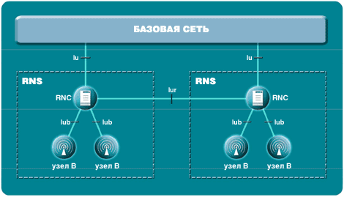
Pic. 5 Architecture UTRAN

5.3.2 Controller of a network of a radio communication (RNC)
Everyone RNC answers for management radio by resources of a set of cells. RNC is an equivalent BSC of a network GSM/GPRS, but more self-controlled. The roles RNC in a network UTRAN can differ:
· the manager RNC
· everyone RNC answers for resources of the set of cells and for Units B in RNS. In this role RNC refers to as as the manager RNC (CRNC)
· serving RNC
· for everyone connected UE controllers RNC can play an additional role: serving RNC (SRNC), ensuring connected UE radio by resources. SRNC is the termination Iu in a direction to CN
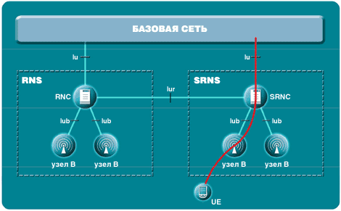
Pic. 6 Serving RNC
· drifting RNC
· minimize influences from transfer of service, the controllers RNC can play a third role: drifting RNC (DRNC). DRNC gives ("gives in temporary usage") resources to the controller SRNC for concrete UE. Usually DRNC also work as SRNC (or DRNC) for others UE.
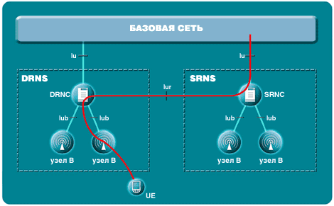
Pic. 7 Drifting RNC

5.3.3 Unit B
Unit B provides transfer and reception of signals in one or more cells like BTS in a network GSM. Unit B also answers for the control of a level of capacity on an internal loop. Please, address to section 3.5 behind the detailed information on the control of a level of capacity.

5.3.4 Equipment of the user (UE)
The equipment of the user (UE) is an equivalent of mobile station (MS) in GSM, i.e. it is the terminal, with which help the user receives access to a network. UE consists of the equipment of mobile communication (terminal) and universal module of identification of service (USIM). The equipment of mobile communication is identified by a unique image with the help IMEI. To permit additional modernization, the terminal equipment should have the interface of applied programming (API). USIM provides personal mobility, giving the user access to services, on which the subscriber is signed. As against a SIM-card in GSM the card USIM can support a set of structures. Each structure will have the concrete purpose. It can be used for regulation of accessible services depending on opportunities of the terminal, in which the card USIM is established. Both user, and network can adjust structures.

5.4 Elements of a base network
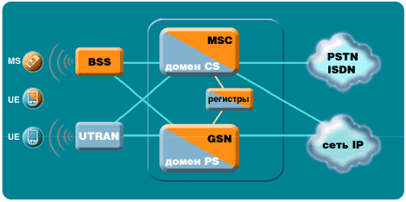
Pic. 8 Architecture of a network UMTS
The base network (CN) is logically divided on the domain CS and domain PS. Besides the set of databases (registers - "Registers") for preservation of the information necessary system is used. Different elements in domains are described below.

5.5 Elements of a base network - domain of switching of channels (CS)
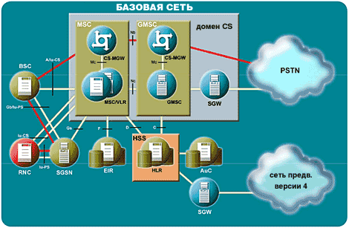
Pic. 9 Elements of a base network - domain CS

5.5.1 Centre of switching of mobile communication / the sluice centre of switching of mobile communication (MSC/GMSC)
The central component of the domain CS in CN is MSC. MSC is a switching station, which carries out all functions of switching and signal system for MS, located in a geographical zone nominated as a zone MSC. The basic distinction between MSC and switching station in a stationary network is, that MSC should take into consideration influence of distribution of radio of resources and mobility of the subscribers. It means, that MSC should carry out such procedures, as:
· procedures necessary for registration of a site
· procedures necessary care of service
MSC/GMSC Represents the interface between system of a radio communication and stationary networks. MSC carries out all functions necessary for processing of services with switching of channels in a direction to and from mobile stations. MSC answers for management of connection (adjustment, routing, management and end of connections), management of transfer of service between MSC and management of additional services, and also for the tax of the information about the payment / account of the users. MSC is connected to the registers of a site and equipment and another MSC in the same network.
GMSC works as a sluice for connection with other networks of mobile communication and switched networks of general usage (telephone network, ISDN, network of transfer of the data).
To ensure radio a covering given of a geographical zone, some base stations usually are required; everyone MSC should cooperate with several base stations. Besides for maintenance of a covering of the country it can be required a little MSC.

5.5.2 Sluice of environment / server of the centre of switching of mobile communication (MGW/server MSC)
To ensure in the version 4 network architecture CS, not dependent from the carrier (and, hence, to ensure universal IP-networks), MSC is shared on a sluice of environment (MGW), ensuring transfer of the user data, and server MSC for maintenance of the signal system. Server MSC consists, mainly, of two parts: managements of connections (CC) and management of mobility MSC. The division on MGW and server MSC also results in creation of more independent environment for service. The new functionalities CAMEL take benefit from this concept, when the management of service becomes independent from the device of switching.
MGW is terminal item of a transport network PSTN/PLMN and connects UTRAN with CN through the interface Iu. MGW can serve the termination of channels - carriers (B-channel&) in a network with switching of channels and flows of the given different formats in a network with switching of packages (for example, flows RTP (transport protocol of real time) in a IP-network).

5.5.3 Sluice of the signal system (SGW)
The sluice of the signal system (SGW) will transform the information of the signal system (in both directions) at a transport level between the signal system on base SS7, used in networks up to the version 4, and signal system on the basis of the protocols IP, which will be probable to be used in post - R99 networks (between SCTP/IP Sigtran and MTP SS7). SGW does not interpret the messages of an applied level (for example, MAP, CAP, BICC, ISUP), but can interpret below laying a level SCCP (subsystem of management of connections of the signal system) or SCTP (protocol of transfer of management of a flow) to guarantee correct routing of the signal system. The sluice SGW will be necessary for maintenance of a universal IP-network UMTS.
The function of a sluice of the signal system can be realized as a separate element or inside other element.
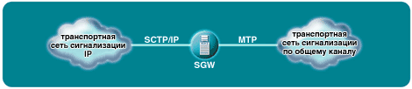
Pic. 10 Functions of a sluice of the signal system

5.6 Elements of a base network - domain of switching of packages (PS)
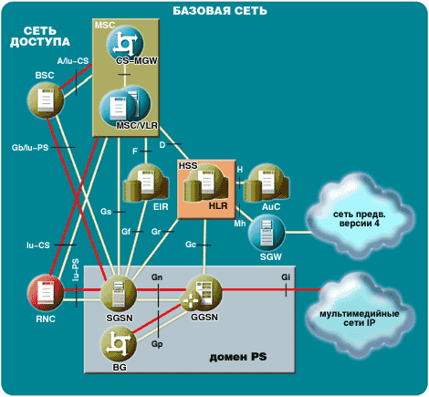
Pic. 11 Elements of a base network - domain PS

5.6.1 Serving unit of support GPRS (SGSN)
SGSN works as the batch switchboard and router in the domain PS of a base network. SGSN operates access of mobile station to a network and router packages in correct BSC/RNC. It carries out functions of management of mobility (MM), as it is made MSC in the domain CS of a base network, such as registration of a site, updating of a zone of routing (RAU) and paging. SGSN also processes functions of maintenance of privacy, such as outidentification and enciphering (between MS/UE and SGSN).

5.6.2 Sluice unit of support GPRS (GGSN)
GGSN works as batch router in the domain PS of a base network and is a sluice between routing of packages IP in a network of mobile communication GPRS/UMTS and routing of packages IP in stationary networks of the Internet. It carries out carry of packages between networks IP-multimedia and appropriate SGSN, which at the current moment serves MS/UE. If MS changes SGSN during a mode of readiness, GGSN is used as buffers of packages of the data. GGSN keeps the data of the subscriber for active MS/UE and the system of protection of access and filtration carries out functions of maintenance of privacy, such as.

5.7 Elements of a base network (CN) - Registers

5.7.1 Home register (HLR)
The home register (HLR) is an independent element of a base network up to and including the version 4. In a network of the version 5 HLR is replaced HSS (server of the subscribers of a home network - see following section), which is the extended variant HLR. HLR includes all administrative information on each subscriber registered in a certain network, information on the solved services and current site of mobile station. The site of mobile station is usually represented in the form of the address of the signal system of the guest register (VLR), connected with MS. Logically there is one HLR on a network, though it can be realized as the distributed database.
HLR provides the following functionalities:
· support of elements in the domain PS, such as SGSN and GGSN through interfaces Gr and Gc. It is necessary to ensure(supply) access of the subscriber to services of area PS
· support of elements in the domain CS, such as MSC/server MSC, through interfaces C and D. It is necessary to ensure(supply) access of the subscriber to services of the domain CS and rouming in traditional networks the GSM/domain CS of a network UMTS.

5.7.2 Server of the subscribers of a home network (HSS)
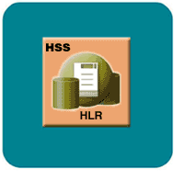
Pic. 12 HSS - extended variant HLR
In a network UMTS of the version 5 HSS replaces HLR. HSS is the extended variant HLR and includes all functionalities HLR plus additional functions for support of functions IM of a subsystem IP-multimedia (IMS). Please, address to section 5.8.
HSS is a general element of domains PS and CS. HSS is a basic database for the given user and contains the information connected to a subscription to support network components processing calls / sessions, for example, support servers of management of connections for performance of procedures of routing / rouming by the decision of interdependence outidentification, authorization, sanction of giving of names / address and definition of a site.
The network UMTS can include one or severaled HSS depending on quantity of the subscribers of mobile communication, throughput of the equipment and organization of a network.
In HSS the following functionalities are provided:
· functionalities IM for maintenance of support of managing functions IMS, such as function of management of a condition of connection (CSCF). It is necessary for providing of access of the subscriber to services of a subsystem IM CN
· the extended set of functions HLR, required for the domain PS
· the extended set of functions HLR, required for the domain CS, if it is required to ensure access of the subscriber to the domain CS or to ensure rouming in traditional networks the GSM/domain CS of a network UMTS.
HSS includes the following information concerning the user:
· the information of identification of the user, numbering and address
· the information on maintenance of protection of the user
· Information of management of access to a network for outidentification and autorisation
· the information on a site of the user at an intersystem level
· HSS provides registration of the users and keeps the information on a site at an intersystem level etc.
· the information on a structure of the user (i.e. installation of parameters for definite purposes)

5.7.3 Guest register (VLR)
The guest register contains the selective administrative information received from HLR, necessary for management of connection and granting of the signed services to each subscriber of mobile communication which is taking place at the present moment in a zone of a site (LA), controlled VLR. Each time at performance MS rouming in new LA the guest register covering this LA, informs HLR on a new site of the subscriber. Then HLR informs VLR on services accessible to the given subscriber. VLR also operates process of giving TMSI.
The registers HLR and VLR together with MSC provide opportunities of routing of calls and rouming in a network. In the majority of realizations VLR is integrated with MSC, and in UMTS of the version 4 will be a part server MSC.

5.7.4 Centre outidentification (AuC)
The centre outidentification is the protected database, which includes individual identification keys of the subscribers (which also are included in SIM) and gives the data of the subscriber in HLR and VLR (through HLR), used for outidentification (check of authenticity) and enciphering of connections.

5.7.5 Register of identification of the equipment (EIR)
The register EIR is a database, which includes the list of all equipment working in a network of mobile communication, and in which everyone MS is identified with the help IMEI. The identifier IMEI is marked as wrong, if the report on theft of mobile station or if MS of the non-authorized type was submitted.

5.8 Subsystem IP-multimedia (IMS)
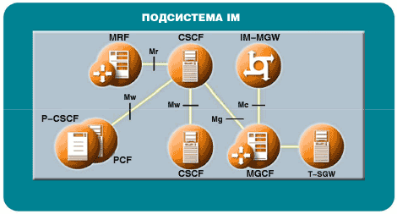
Pic. 13 Subsystems IP-multimedia
The subsystem IMS is the basic difference of a network UMTS of the version 4 from the version 5. IMS includes all elements CN for maintenance multimedia of services. The services IP-multimedia (IM) are based on an opportunity of management of a session certain Working group of engineering problems of the Internet (IETF). The services IM together with multimedia by carriers use the domain PS - probably including an equivalent set of services in the appropriate subset of services CS.
The subsystem IMS allows the operators PLMN to offer multimedia of service to the subscribers, being based on the built - in appendices, services and protocols of the Internet. 3GPP to not aspire standardize such services in limits IMS. The purpose is, that these services should be developed by the operators PLMN and independent suppliers (intermediaries), including services in space of the Internet using mechanisms provided with the Internet and IMS. The subsystem IMS should ensure for the users of a radio communication convergention and access to various technologies: a telephony, a video, message transfer, transfer of the data and technology on base web, and also to unit development of the Internet with development of mobile communication.
Specific functional elements IMS further are described.
CSCF, which plays three roles:
· proxy (Proxy) -CSCF (P-CSCF) is a first contact point for UE in limits IMS. The function of management of strategy (PCF) is a logic element P-CSCF
· interrogating CSCF (I-CSCF) is a contact point within the limits of a network of the operator for all connections IMS, intended to the user of this concrete network operator
· serving CSCF (S-CSCF) carries out services of management of a session for UE
· the function of management of a sluice of environment (MGCF) carries out transformation of the protocols between ISUP (subsystem of the users ISDN) and protocols of management of connections IMS (for example, transformation ISUP/SIP (protocol of initiation of a session))
· the function of set of resources (MFR) carries out functions of collective connections and realizations multimedia of conferences
· the sluice of environment IP-multimedia (IM-MGW) finishes channels - carriers from a network with switching of channels and flows multimedia from a network with switching of packages. The sluice IM-MGW can support transformation of environment, management of the carrier and processing of loading (for example, сodek, echo - equalizer, bridge of a conferencing).

